**Homework 1: Balancing brackets**

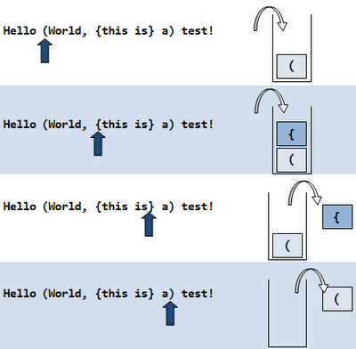Determine whether any given string has a legal bracket structure. Basically, make sure all the ‘(‘, ‘[‘, and ‘{‘ have matching ')', ']', and '}'. You also need to take nesting into account, so that "({)}" is incorrect, and "({} ({}) )" will pass.

If you want you can use my match method:

**public static boolean match(char open, char close){**

**switch(open){**

**case '(': return (close==')');**

**case '[': return (close==']');**

**case '{': return (close=='}');**

**default : return false;**

**}**

**}**